Slide 16 – Module 1. Maturity Levels

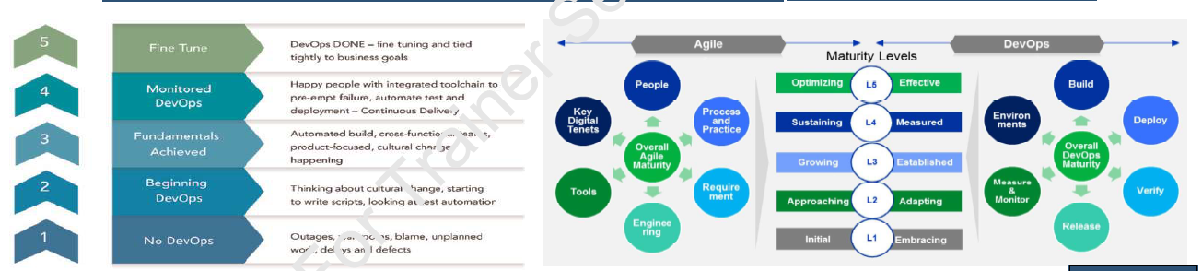

DevSecOps Evolution Stages (Left Section)

DevOps Evolution Stages → DevSecOps Security Integration
- At lower maturity, security is reactive and handled after incidents occur.
- Early DevSecOps introduces basic security scripting and vulnerability scanning.
- Mid-level maturity embeds automated security testing into CI/CD pipelines.
- Advanced stages integrate secure coding, threat modeling, and policy-as-code.
- At the highest level, security is fully aligned with business risk strategy and continuously optimized.

Agile Maturity Model → Secure Agile Culture
- Security becomes part of agile ceremonies, not a separate gate.
- People collaborate across Dev, Sec, and Ops with shared accountability.
- Security requirements are treated as user stories and prioritized in backlogs.
- Engineering practices include secure coding, peer reviews, and automated tests.
- Agile maturity enables faster, safer iterations with built-in security feedback loops.

Maturity Levels (L1–L5) → Security Capability Growth
- L1 (Initial): Security is ad hoc and mostly compliance-driven.
- L2–L3: Standardized security controls and automated scans are introduced.
- L4 (Measured): Security metrics (MTTD, MTTR, vulnerability trends) guide decisions.
- L5 (Optimizing): Continuous threat modeling and proactive risk reduction occur.
- Higher maturity reflects a shift from reactive defense to predictive resilience.

DevOps Lifecycle → Secure Continuous Delivery
- Security checks are embedded in Build through SAST, dependency scanning, and secrets detection.
- During Deploy, infrastructure-as-code and policy enforcement ensure secure environments.
- In Verify, automated security testing and validation occur before release.
- Release and Monitor phases include runtime protection and telemetry-based threat detection.
- Continuous monitoring feeds security insights back into the development backlog.

In one sentence:
The diagram shows how organizations evolve from reactive practices to fully integrated DevSecOps, where security is automated, measured, and embedded across the entire value stream.

Slide 23 – Module 1

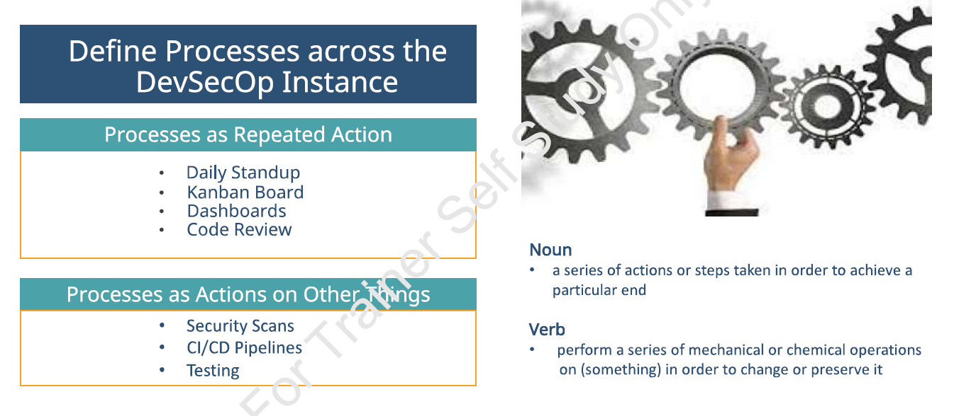
This slide explains that in DevSecOps, a process is both a structured workflow and an active transformation mechanism.
As a noun, a process is a defined series of steps like daily standups, code reviews, or deployment workflows.
As a verb, a process means executing actions that transform something, such as CI/CD pipelines processing code or security scans analyzing artifacts.
DevSecOps requires both human processes for collaboration and automated processes for validation and delivery.
When defined processes are consistently executed and automated, they create reliable, repeatable, and secure software delivery.

Big Idea of the Slide
In DevSecOps, a process is not just documentation.
It is:
- A repeated structured activity
- And a mechanism that transforms work
The gears image reinforces this idea — processes make the system move smoothly.

Processes as Repeated Action
These are team rituals or structured routines:
- Daily Standup
- Kanban Board
- Dashboards
- Code Review
These are behavioral processes.
They create:
- Transparency
- Collaboration
- Flow
- Continuous improvement
They are things the team does regularly.

Processes as Actions on Other Things
These are technical/system processes:
- Security Scans
- CI/CD Pipelines
- Testing
These processes act on:
- Code
- Artifacts
- Infrastructure
They transform or validate them.
These are automation-driven processes.

Why “Noun” and “Verb” Are Shown
The slide is teaching a deeper concept.
Process as a Noun
“A series of actions taken to achieve an end.”
This means:
- A defined workflow
- A structured method
- A documented procedure
Example:
“Our deployment process.”
This is process as a thing.

Process as a Verb
“To perform operations on something to change or preserve it.”
This means:
- Executing transformations
- Running pipelines
- Processing data/code
Example:
“The CI pipeline processes the code.”
This is process as action.

Why This Matters in DevSecOps
DevSecOps requires both:
✔ Human processes (collaboration rituals)
✔ Automated processes (technical transformations)
If you only define processes (noun) but don’t execute them (verb), nothing changes.
If you automate without structure, chaos happens.
DevSecOps is about:
Defined processes + automated execution + continuous repetition.

Summary
This slide teaches that in DevSecOps, a process is both a structured workflow (noun) and an active transformation mechanism (verb), combining team practices like standups with automated systems like CI/CD and security scans to create continuous, reliable delivery.

Slide 33 – Module 1

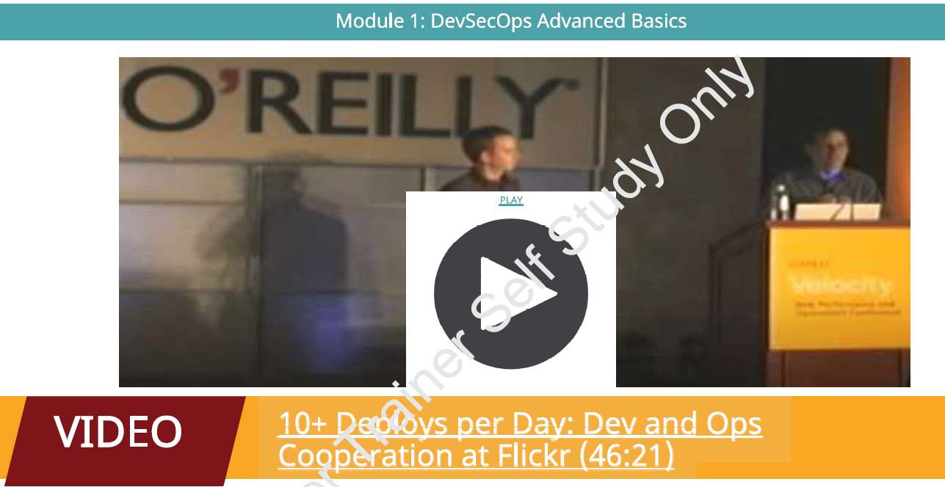

The video “10+ Deploys per Day: Dev and Ops Cooperation at Flickr” explains how Flickr transformed its software delivery process by adopting DevOps practices to enable frequent and reliable deployments.
- The speaker explains the challenges Flickr faced with traditional development and operations working in silos.
- Releases were slow, risky, and often caused downtime due to poor coordination between teams.
- Flickr introduced a culture of collaboration where developers and operations teams worked closely together.
- The organization began automating build, testing, and deployment processes to reduce manual errors.
- Continuous integration and automated deployment pipelines allowed code to move quickly from development to production.
- The concept of “10+ deployments per day” demonstrated that smaller, frequent releases reduce risk compared to large infrequent releases.
- Monitoring, logging, and quick rollback mechanisms were introduced to handle failures efficiently.
- The talk emphasizes the importance of culture, trust, and shared responsibility in DevOps adoption.
- Tools and scripts were used to standardize deployment processes and ensure consistency.
- The approach improved system reliability, faster delivery of features, and better response to user needs.
- The video highlights how DevOps practices improve collaboration, speed, and operational stability.
- Overall, it shows how integrating development and operations enables organizations to achieve rapid and continuous software delivery.

